VAIDYACURE
Designed by:
SATYAM KUMAR SINHA (2023PUFCEBCEX14464)
SHASHWAT SAMARTH (2023PUFCEBCEX14307)
SUNNY BAIRAWA
SAURABH KUMAR (2023PUFCEBCEX15307)
Of
POORNIMA UNIVERSITY
(B. Tech CE Section – J)

Guided by - Ms. AASHA SONI
Acknowledgement
I would like to express my sincere gratitude to my project guide for their valuable guidance, continuous support, and encouragement throughout the development of this project. Their insights and suggestions played a crucial role in the successful completion of this work.
I am also thankful to the faculty members of my department and my institution for providing the necessary resources and a conducive environment for learning and development.
I extend my appreciation to my friends and peers who supported me with their suggestions and feedback during the project.
Lastly, I would like to thank my family for their constant motivation and support, which helped me complete this project successfully.

Abstract
This project presents a mobile application that provides a comprehensive and organized collection of medications, including allopathic, homeopathic, and herbal remedies. The primary objective of the application is to simplify access to medication-related information by allowing users to search and filter medicines based on symptoms.
The application offers a user-friendly interface where users can explore categorized medication lists and select specific medicines to view detailed information such as dosage, preparation methods, and possible harmful effects. This ensures that users receive structured and relevant information in an efficient manner.
Additionally, the system includes an admin panel for managing and updating the medication database. The admin can update data through two methods: direct manual entry and CSV file upload. In the CSV method, existing data can be downloaded, modified offline, and re-uploaded, making the system flexible and scalable for handling large datasets.
The application aims to bridge the gap between scattered medical information sources by providing a centralized platform. Future enhancements include the integration of diagnostic features to assist users in identifying conditions and recommending suitable medications based on symptoms.

Table of Contents
- Title Page
- Acknowledgement
- Abstract
- Table of Contents
- Introduction
- Problem Statement
- Literature Review / Existing System
- Proposed System
- Technology Stack
- System Design
- Implementation
- Results / Output
- Conclusion
- Future Scope
- References
- Appendix

Introduction
With the rapid advancement of mobile technology, smartphones have become an essential tool for accessing information in various domains, including healthcare. However, medication-related information is often scattered across multiple sources, making it difficult for users to find accurate and relevant details quickly. Additionally, most existing applications focus on a single system of medicine and lack proper filtering mechanisms based on symptoms.
This project aims to develop a mobile application that provides a unified platform for accessing information on allopathic, homeopathic, and herbal medications. The application allows users to search and filter medicines based on specific symptoms, enabling a more efficient and user-friendly experience. By selecting a particular medication, users can view detailed information such as dosage, preparation methods, and potential harmful effects.
The system also includes an admin panel that facilitates easy management and updating of medication data. The admin can either directly input new data or update existing records through a CSV file upload mechanism, ensuring flexibility and scalability.
The main objective of this project is to create a dependable, organized, and accessible solution for users seeking medication information. By combining multiple systems of medicine into a single platform, the application enhances usability and simplifies the process of finding suitable remedies.

Problem Statement
In today’s digital age, users often struggle to find accurate and well-organized medication information for specific symptoms. Existing platforms are either limited to a single system of medicine, such as allopathy, or lack proper filtering mechanisms that allow users to search based on symptoms. This results in confusion, inefficiency, and increased dependency on multiple sources.
Furthermore, many applications do not provide comprehensive details such as dosage, preparation methods, and potential harmful effects in a structured manner. This creates a gap between available information and user accessibility.
Another major issue is the difficulty in maintaining and updating large datasets of medications. Traditional systems often lack flexible and efficient data management methods, making updates time-consuming and error prone.
Therefore, there is a need for a centralized mobile application that:
- Integrates multiple systems of medicine (allopathic, homeopathic, and herbal)
- Provides symptom-based filtering and search functionality.
- Displays detailed and structured medication information.
- Includes an efficient admin panel for easy data management and updates.
This project aims to address these challenges by developing a user-friendly and scalable solution.

Literature Review / Existing System
Various mobile applications and digital platforms are available that provide information about medications and treatments. These include general healthcare apps, pharmacy platforms, and symptom checkers. While these systems offer useful information, they have several limitations.
Most existing applications focus primarily on a single system of medicine, such as allopathy, and do not integrate alternative approaches like homeopathy or herbal treatments. This restricts users from exploring multiple options in one place.
Additionally, many platforms lack efficient symptom-based filtering. Users often need to search for medications, which can be time-consuming and confusing. Some applications provide excessive or unstructured information, making it difficult for users to identify relevant details such as dosage, preparation methods, and side effects.
Another limitation is related to backend data management. Many systems do not provide flexible methods for updating large datasets, which can lead to outdated or inconsistent information.
These drawbacks highlight the need for a more comprehensive and user-friendly system that integrates multiple types of medication, supports symptom-based filtering, and allows efficient data management. The proposed system aims to overcome these limitations by providing a centralized and well-structured platform.

Proposed System
The proposed system is a mobile application designed to provide a centralized and well-organized platform for accessing medication information across multiple domains, including allopathic, homeopathic, and herbal treatments. The system focuses on improving user experience by enabling symptom-based search and structured presentation of medication details.
The application allows users to input symptoms and view a filtered list of relevant medications. Each medication entry provides comprehensive information such as dosage, preparation methods, and potential harmful effects, helping users make informed decisions.
A key component of the system is the admin panel, which ensures efficient management of the medication database. The admin is provided with two flexible methods for updating data. The first method involves direct manual entry of medication details into the system. The second method allows the admin to download the existing dataset in CSV format, update or modify it offline, and then re-upload it to the system. This approach simplifies bulk updates and improves scalability.
The system is designed with modular architecture, ensuring ease of maintenance and future enhancements. It aims to overcome the limitations of existing systems by integrating multiple types of medication, providing efficient filtering, and enabling seamless data management.

Technology Stack
The mobile application is developed using the MERN stack, which ensures robust, scalable, and efficient system architecture.
Frontend:
The user interface is built using React Native, allowing the application to run smoothly on mobile devices with a responsive and user-friendly design.
Backend:
The backend is developed using Node.js along with Express.js, which manages server-side logic, API creation, and communication between the frontend and the database.
Database:
The application uses MongoDB, a NoSQL database, to store medication data such as symptoms, categories, dosage, preparation methods, and harmful effects in a flexible and structured format.
Admin Panel:
The admin panel is also developed using React, enabling efficient management of medication data. It supports:
- Direct data entry
- CSV file upload for bulk updates
Development Tools:
- Visual Studio Code
- Git (for version control)
Other Technologies:
- CSV file handling for import/export of data
- RESTful APIs for communication between frontend and backend
The MERN stack provides high performance, flexibility, and scalability, making it suitable for developing modern mobile applications.
System Design
The system is designed using modular architecture that ensures smooth interaction between the mobile application, backend server, and database. The design focuses on efficiency, scalability, and ease of maintenance.
1. Overall Architecture
The application follows a three-tier architecture:
- Frontend (Mobile App): Built using React Native, responsible for user interaction and displaying data.
- Backend (Server): Developed using Node.js and Express.js, oversees business logic and API requests.
- Database: MongoDB is used to store and manage medication data
2. User Flow
- User enters symptoms in the application.
- The system processes the input and sends a request to the backend.
- The backend fetches relevant data from the database.
- Filtered medication results are displayed to the user.
- Users select a medication to view detailed information.
3. Admin Flow
- Admin logs into the admin panel
- Admin can update medication data using two methods:
  - Direct entry of new or modified data
  - CSV file upload after offline editing
- Updated data is stored in the MongoDB database.
- Changes are reflected in the mobile application.
4. Data Flow
- User input → Frontend → API request → Backend → Database
- Database response → Backend → Frontend → Display to user
5. Key Components
- User Interface Module
- Search and Filter Module
- Medication Detail Module
- Admin Management Module
- Database Management System
This design ensures efficient data handling, fast response time, and flexibility for future enhancements such as diagnostic features.

Implementation
The implementation of the mobile application is conducted using the MERN stack, ensuring a structured and efficient development process. The system is divided into multiple modules, each responsible for specific functionalities.
1. User Module
The user module provides an interactive interface where users can:
- Enter symptoms to search for medications.
- View filtered lists of medicines based on input.
- Navigate through categorized medication types (allopathic, homeopathic, herbal)
2. Search and Filter Module
This module processes user input and applies filtering logic:
- Matches symptoms with stored data in the database.
- Retrieves relevant medication records.
- Displays results in a structured format.
3. Medication Detail Module
When a user selects a medication, detailed information is displayed, including:
- Dosage instructions
- Preparation methods (if applicable)
- Possible harmful effects
This ensures users receive complete and organized information.
4. Admin Module
The admin panel is implemented to manage and update the database efficiently. It supports two methods:
a) Direct Entry Method:
- Admin manually enters or edits medication details through a form interface.
b) CSV Upload Method:
- Admin downloads existing data in CSV format
- Updates the data offline using tools like Excel.
- Re-uploads the CSV file to update the database.
This dual system improves flexibility and supports bulk data operations.
5. Backend Implementation
- RESTful APIs are created using Node.js and Express.js
- APIs handle requests such as fetching data, filtering results, and updating records.
- Data validation and processing are performed before storing in the database.
6. Database Implementation
- MongoDB is used to store structured medication data.
- Collections include fields such as symptoms, category, dosage, preparation methods, and harmful effects.
- Data is organized for efficient querying and retrieval.
The implementation ensures that the application is scalable, efficient, and capable of handling real-time user requests effectively.

Results / Output
The developed mobile application successfully achieves its intended objectives by providing a structured and user-friendly platform for accessing medication information.
The application allows users to:
- Search for medications based on symptoms.
- View categorized lists of medicines (allopathic, homeopathic, and herbal)
- Access detailed information including dosage, preparation methods, and harmful effects
The search and filtering functionality works efficiently, providing accurate and relevant results based on user input. The user interface is designed to be simple and intuitive, ensuring ease of navigation.
The admin panel also functions effectively, enabling smooth data management through both direct entry and CSV upload methods. Bulk data updates using CSV files significantly reduce manual effort and improve efficiency.
Overall, the system demonstrates reliable performance, fast data retrieval, and accurate information display. The integration of frontend, backend, and database components ensures seamless operation of the application.
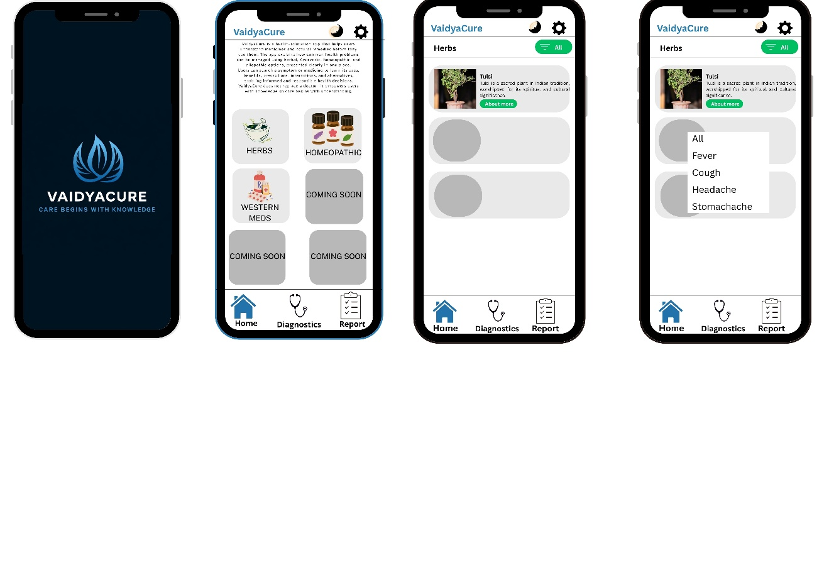
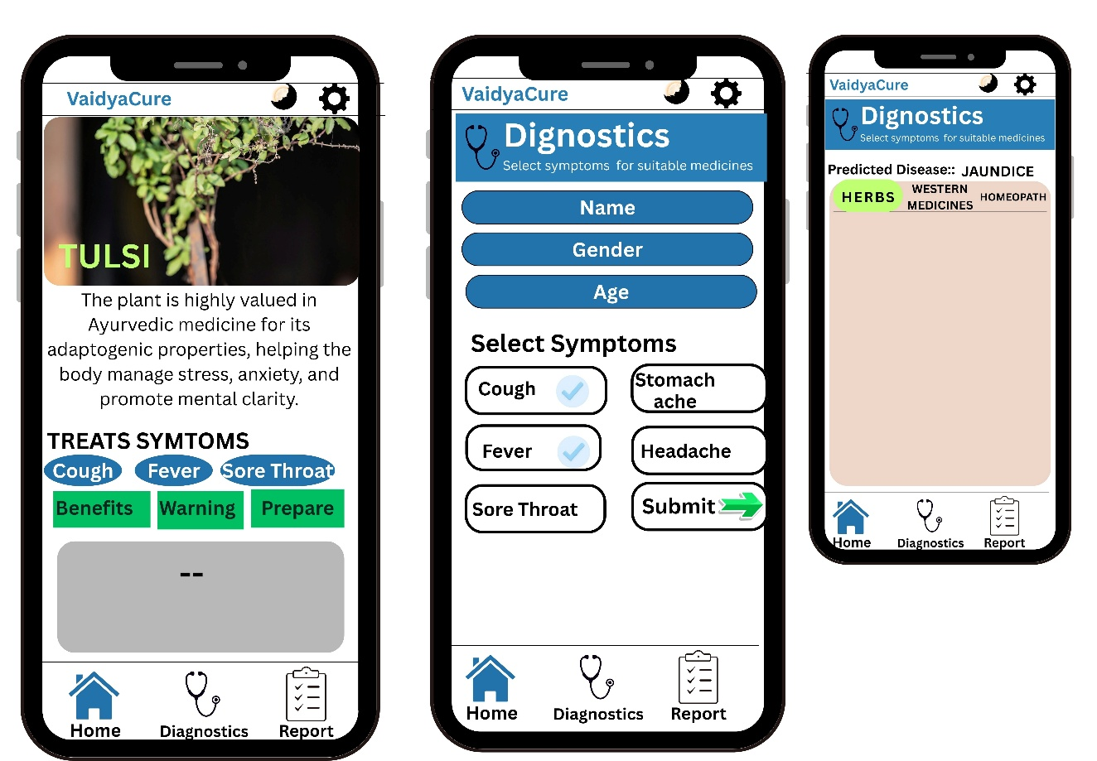

Conclusion
The mobile application developed in this project successfully provides a centralized platform for accessing medication information across multiple systems, including allopathic, homeopathic, and herbal treatments. The application effectively addresses the problem of scattered and unorganized medical data by offering a structured and user-friendly solution.
The implementation of symptom-based filtering enables users to quickly find relevant medications, while the detailed information provided for each medicine enhances usability and awareness. The integration of an admin panel with both direct entry and CSV upload methods ensures efficient data management and scalability of the system.
The use of the MERN stack contributes to the overall performance, flexibility, and maintainability of the application. The system demonstrates reliable functionality, smooth user interaction, and efficient data handling.
In conclusion, the project achieves its objectives and provides a sturdy foundation for further enhancements in the field of digital healthcare applications.

Future Scope
The current application provides a sturdy foundation for accessing and managing medication information; however, several enhancements can be implemented to improve its functionality and effectiveness.
One major future enhancement is the integration of a proper diagnostic system that can intelligently analyze user-input symptoms and provide possible medical conditions along with suitable medication suggestions. This system can be designed as a multi-step process where users input symptoms, duration, severity, and other relevant factors. Based on this data, the system will match patterns from the database and generate probable diagnoses with corresponding treatment options.
The diagnostic module can be further enhanced by:
- Implementing AI/ML algorithms to improve accuracy over time
- Providing risk-level indicators (mild, moderate, severe) for better decision-making
- Suggesting whether professional medical consultation is required.
- Incorporating decision-tree or rule-based logic for initial diagnosis
- Allowing continuous updates with verified medical datasets
Additional improvements may include:
- User accounts and profiles to save medical history and preferences.
- Cloud synchronization for real-time updates
- Multilingual support for wider accessibility
- Advanced filtering and smart search options
These enhancements will transform the application from an information-based platform into an intelligent healthcare assistant, improving both usability and practical value.
References
- Official documentation of MongoDB – for database design and data management
- Official documentation of Node.js and Express.js – for backend development and API creation
- Official documentation of React Native – for mobile application development.
- Tutorials and guides from platforms such as W3Schools, GeeksforGeeks, and MDN Web Docs
- Online resources related to CSV file handling and data processing.
- General medical and healthcare information sources used for understanding medication details.
All the above references were used for learning, development, and implementation of the project.

Appendix
The appendix section includes additional supporting materials and information related to the project that are not included in the main report.
1. Sample Data Format (CSV)
The application uses CSV files for bulk data updates in the admin panel. The typical structure of the CSV file is as follows:
- Medication Name
- Category (Allopathic / Homeopathic / Herbal)
- Symptoms
- Dosage
- Preparation Method
- Harmful Effects
2. Screenshots
(Screenshots of the application interface can be included here, such as:)
- Home screen
- Symptom search screen
- Medication list screen
- Medication detail screen
- Admin panel interface
3. API Endpoints (Example)
- GET /medications → Fetch all medications.
- POST /medications → Add new medication.
- PUT /medications/:id → Update medication.
- DELETE /medications/:id → Delete medication.
4. Additional Notes
- The system supports both manual and bulk data updates.
- CSV format is used for easy data handling and scalability.
This section provides supplementary details that support the overall understanding and implementation of the project.

